# Inverse Gaussian distribution

Def

PDF

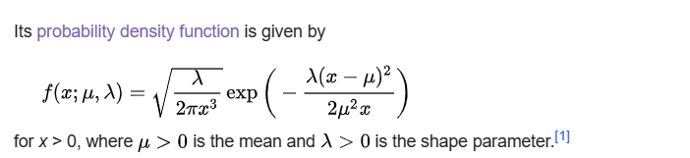

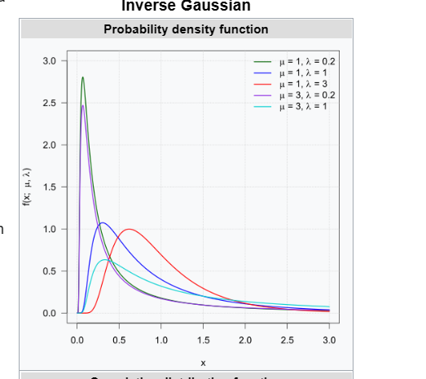



CDF

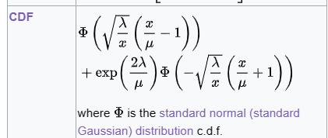

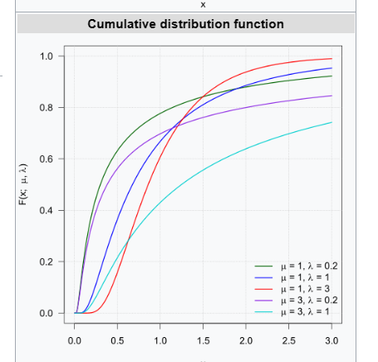

Expected Value

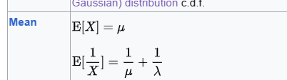

Variance

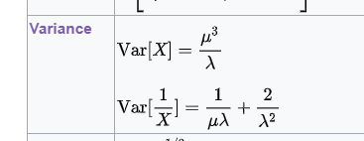

Mode

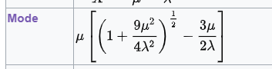

Skewness



Ex. Kurtosis



MGF



CF

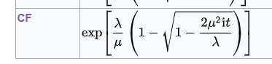

Ref

[Inverse Gaussian distribution - Wikipedia](https://en.wikipedia.org/wiki/Inverse_Gaussian_distribution)